Study on Energy Savings Based on Lighting System Using Low-Cost Home Energy Management System (HEMS)

Nurnaili Afifah Mohd Rusli¹, Farahiyah Mustafa¹*, Sim Sy Yi¹, Nor Aira Zambri¹

¹Department of Electrical Engineering Technology, Faculty of Engineering Technology, Universiti Tun Hussein Onn Malaysia, 84600 Pagoh, Johor, MALAYSIA

*Corresponding Author Designation

DOI: https://doi.org/10.30880/peat.2022.03.01.043
Received 17 January 2022; Accepted 11 April 2022; Available online 25 June 2022

Abstract: As the population and economic growth rapidly, demand on energy consumption also rising in many countries nearly every year for at least half a century based on the article of energy production and consumption by Hannah Ritchie and Max Roser. The study focused on design and development of low-cost energy monitoring to monitor the energy consumption on lighting system for HEMS and thus study on the energy savings evaluation. This study used 12W, 24W and 48W lighting points as to measure and differentiate the energy consumption thus the energy savings for the HEMS. Based on the results, it shows that the energy metering for monitoring the HEMS came to triumph as it displays the output of the current, power, peak power and energy consumption that also leads to the successful of the study on energy savings of the HEMS as it shows that the low wattage loads with higher energy efficiency has the highest total annual energy savings for a long period of time. By practicing this study, the production of energy wasted and energy consumption reduced as the energy savings increasing for the HEMS.

Keywords: Energy Consumption, Energy Savings, HEMS, Arduino UNO, Total Annual Energy Savings

- Introduction
One-third of the contributing factor in primary energy consumption are homes and buildings. According to the International Energy Agency (IEA), the demand for energy use in the world is expected to increase by more than two-thirds by the year 2035 [1]. The statement made is based on the rapid population growth face by many countries that have become a quite temporary phenomenon.
Energy management systems (EMS) are widely known systems in this 21st century where the technologies are becoming more and more advance in a split second. EMS is an automation system that collects energy measurement data and making it available for users to access and monitor their energy consumption thus manage the energy resources smartly. Renewable energy (RE) is part of the driving force to enhance the energy efficiency, protect natural resources and improve quality of life [2]. RE can provide an energy solution that reduces the negative impact on the environment [3]. The data collection of energy consumption used and energy losses produced on small homes and buildings will be taken for EMS. From the data, the development of the EMS will begin where all the electrical components or equipment changed with higher energy efficiency equipment to help in cut down the costs. As already know, the use of fluorescent light for 24/7 operation takes up to 376 kWh per bulb without including the other electrical uses. Just imagine how much energy waste would be produced daily in this condition. If all fluorescent lights are changed to light emitting diode (LED) lights which high in energy efficiency, the wattage consumed by the lights will reduce even if the amount of LED lights being installed double the amounts of fluorescent lights used before. An increase in the numbers of equipment with higher energy efficiency will decrease the wattage consumed by the house. In order to provide optimal working conditions for the lighting, the lights can be control under set conditions or times by the users in which to automatically turn on, off or dim [4]. The concepts of “Corridors of light” to follow the movement of people in the building by using the occupancy sensors [5].
Moreover, the installation of Internet of Energy (IoE) helps the users to monitor and manage or minimize their energy usage. The user can either control the working hours of their energy usage or change their home appliances into smart energy appliances that have energy star certification. The energy star certification shows that the appliances have good energy efficiency even it consumes less power. In this project, the energy consumption is being managed by reduce the working hours from 18 hours to 12 hours and 6 hours and also reduce the wattage of the lighting system used from 48 watts to 24 watts and 12 watts.
- Materials and Methods
Lamp is used as the load for data collecting of this project. The total load used for this project is 12 W, 24 W and 48 W and the data are collected on every 6 hours, 12 hours and 18 hours for each load. The Energy Management System (EMS) that being applied in this project is by changing the value of loads with the higher energy efficiency thus while running on the same working hours. The calculation of energy savings for each load can be obtained by differentiate the energy consumption read by the energy meter for the three different loads value. Figure 1 shows the workflow overview of the project.
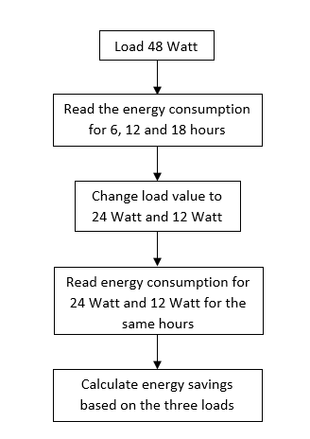
Figure 1: Workflow Overview of HEMS

2.1 Methods
In this section, the implementation of home energy management system (HEMS) is discussed, as shown by the block diagram of the EMS in Figure 2 using the main components and the load with 48 W, 24 W and 12 W used to achieve the energy savings. Furthermore, the full process of the system will be shown in the flowchart as in Figure 8.
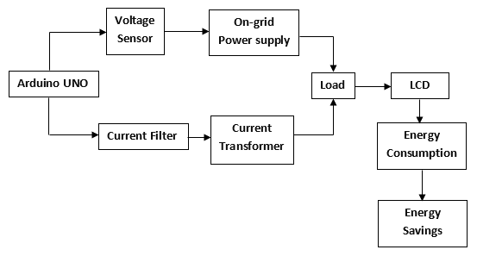
Figure 2: Block Diagram of Home Energy Management System
Figure 3 shows the full process of the project in managing the energy consumption. The on-grid power supply is used in this project as to turn on the lamp of 24 W and 12 W respectively. Meanwhile, the voltage sensor detects and measure the incoming voltage and the current transformer detects and measure the primary winding current. If the current transformer detects the primary current exceeded, then it will trip the system which works as a protection to the equipment. Later, the reading of current, power, peak power and energy consumption are being measured and recorded at certain period of time of 6, 12 and 18 hours. At the end of the process, the energy savings are verified by calculating the total annual energy savings of the project when the system change the load value from 48 W load to 24 W and 12 W load.

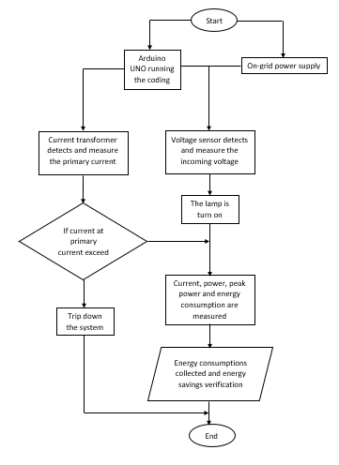
no
yes
Figure 3: Flowchart of the Monitoring HEMS
2.2 Materials
Specifications and properties of the components used and needed in this project are listed as below.

Arduino UNO R3
Arduino UNO R3 as shown in Figure 4 is a microcontroller that is use to program the project. This Arduino is based on the ATmega328p in which having 20 digital input/output pins; 6 of them used as PWM outputs and another 6 are used as analogue inputs. The coding is uploaded on the Arduino by connecting the Arduino with a computer as to run the project.
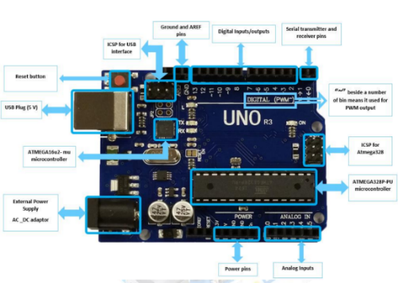
Figure 4: Arduino UNO R3

Voltage Sensor
Figure 5 shows the sensor used which is the voltage sensor to determine, calculate and monitor the incoming voltage through the load. This voltage sensor used the concept of voltage divider to measure the voltage. The implementation of voltage sensor for the project helps in a more conventional voltage measurement method.
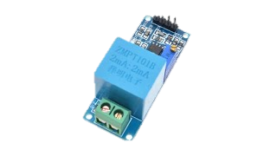
Figure 5: Voltage Sensor

LCD Display
LCD display shows in Figure 6 is a device used to display the output of the project such as the current (A), voltage (V), power (kW) and total energy consumption (kWh). The operation of LCD used liquid crystal as its primary form to display the outputs available.
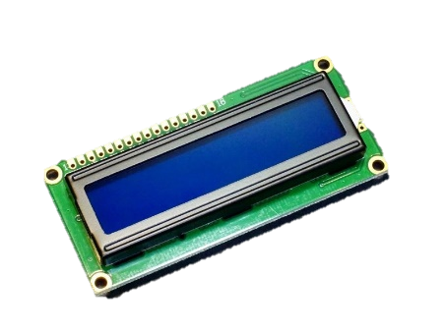
Figure 6: Liquid Crystal Display (LCD)

Current Transformer
Current transformer is an instrument transformer that carry the objectives of measurement and protection purposes to the equipment. The CT used in the project as shown in Figure 5, is to prevent the equipment from over current by measure and then stepping down the current of the primary winding.
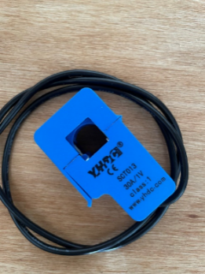
Figure 7: Current Transformer (CT)
2.3 Hardware Design and Development
The schematic design of the monitoring system for data collection on the HEMS shown in Figure 8.
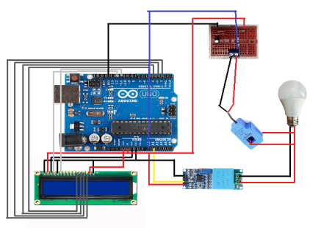
Figure 8: Schematic Diagram of The Monitoring HEMS
2.4 Equations
1. Energy Consumption
All electronic devices or equipment have different usage of power and their working hours for them to function properly. The information of maximum power and etc are provided on the product’s label by the manufacturing company in which normally the reading is not accurate due to several factors. Equations on energy consumption and total energy cost are provided as below:

- Energy Consumption per Appliances as in Eq.1

$E=P ×t$ Eq.1
where;
E = Energy consumption in kWh
P = Power of electrical appliance in kW
t = Time on electrical consumption in h.
2. Energy Savings
Energy savings can be reached by either change the appliances that have higher energy efficiency or reduce the working hours of the appliances smartly. Energy savings can be calculated using the sets of equation listed:
  - Energy Savings per Bulb as in Eq. 2

$E.S.B=Old Product-New Product$ Eq. 2
where;
E.S.B = Energy savings per bulb in W.

  - Annual Running Time as in Eq. 3

$T.A.R.T=Working hours \left(h\right)×360$ Eq. 3
where;
T.A.R.T = Total annual running time in h.

  - Total Annual Energy Savings as in Eq. 4

$T.A.E.S=\frac{(E.S.B ×T.A.R.T)}{1000}$ Eq.4
where;
T.A.E.S = Total annual energy savings in kWh
E.S.B = Energy savings per bulb in W
T.A.R.T = Total annual running time in h.
- Results and Discussion
For this chapter, the final design of the Home Energy Management System (HEMS) is presented along with the results obtained which consists of the energy consumption for one load using on-grid power supply and using solar panel, energy consumption for four load using on-grid power supply and using solar panel, and thus the energy savings for both loads situation. The solar panel with 50 watt of power is chosen as the second power source to differentiate the total energy consumption (kWh) as to reach the objective of energy savings.
3.1 Results
The data on energy consumption 48 W load for total of 6 hours, 12 hours and 18 hours are collected beforehand as the baseline data to calculate the energy savings by comparing them with the data of energy consumptions for total loads of 12 W and 24 W running at the same working hours.
1. Energy Consumption of 48 W Load
Table 1 shows the baseline data of the energy consumption of 48W load. The table also shows the expected of energy consume for certain hours that can be compared to the other two loads value that running for the same working hours to calculate the energy savings later.
Table 1: Energy Consumption of 48 W Load
Load | Working Hours (h) | Energy Consumption (kWh)
48 W Lamp | 6 | 0.29
 | 12 | 0.58
 | 18 | 0.87

2. Energy Consumption of 24 W Load
Table 2 shows the energy consumption of 24 W load. The table also shows the expected of energy consume for certain hours that can be compared to the results that came out from the project.
Table 2: Energy Consumption of 24 W Load
Load | Working Hours (h) | Expected Energy Consumption (kWh) |  | Real Energy Consumption (kWh)
24W Lamp | 6 |  | 0.14 | 0.14
 | 12 |  | 0.29 | 0.30
 | 18 |  | 0.43 | 0.48

From the results, it appears that the real energy consumption (kWh) produced are slightly different for the 12 and 18 working hours as the expected energy consumption (kWh). This shows that the proposed HEMS project is having a little distortion in the current detected.
3. Energy Consumption of 12 W Load
Table 3 shows the energy consumption for the 12 W load. The table also shows the expected of energy consume for certain hours that can be compared to the results that came out from the project.
Table 3: Energy Consumption 12 W Load
Load | Working Hours (h) | Expected Energy Consumption (kWh) | Real Energy Consumption (kWh)
12W Lamp | 6 | 0.07 | 0.06
 | 12 | 0.14 | 0.14
 | 18 | 0.21 | 0.21

From the data obtained, the real energy consumption (kWh) is slightly different from the expected results for a total of 6 working hours (h). This can be caused by the error percentage that present in the energy metering.
4. Energy Consumption for Three Loads Value
The data on energy consumptions for the three loads that collected are represented in Table 4.

Table 4: Energy Consumption for Three Loads Value
Load (W) | Working Hours (h) | Energy Consumption (kWh)
12 | 6 | 0.06
 | 12 | 0.14
 | 18 | 0.21
24 | 6 | 0.14
 | 12 | 0.30
 | 18 | 0.48
48 | 6 | 0.29
 | 12 | 0.58
 | 18 | 0.87

From the data obtained, it shows that the energy consumption for 12 watts load is less than the 24 watts and 48 watts loads as it has higher energy efficiency that used less power to give the same output performance as the other two loads. From the result for the 24 watts load, during the 6 hours period it already produce 0.14 kWh which double the amount of energy consumption for 12 watts load for the same period. Meanwhile, the energy consumes by the 48 watts load at 6 working hours already triple the amount of energy consumption for the 12 watts at the same time. Figure 9 shows the graph on the energy consumption by each load where the grey line shows the energy consumption for 48 W load, the orange line for 24 W load and the blue line for 12 W.

Figure 9: Graph on Energy Consumption for Each Load
From the graph, it is concluded that the energy consumption for the 12 W load is the lowest even if it produces the same amount of light as it contains higher energy efficiency than the 24 W and 48 W loads.
5. Energy Saving Calculations
After the data obtained for the energy consumptions for each load, the energy savings are verified by comparing the results of 24 W and 12 W loads with the old product wattage which is the 48 W load. The total annual energy savings obtained are shown in Table 5.

Table 5: Total Annual Energy Savings
Old Product Load (W) | New Product Load (W) | Energy Savings per Bulb (W) | Working Hours (h) | Annual Running Time (h) | Total Annual Energy Savings (kWh)
48W | 12W | 36W | 6 | 2160 | 77.76
 |  |  | 12 | 4320 | 155.52
 |  |  | 18 | 6480 | 233.28
 | 24W | 24W | 6 | 2160 | 51.84
 |  |  | 12 | 4320 | 103.68
 |  |  | 18 | 6480 | 155.52

Figure 10 also shows the graph on the total annual energy savings for the new product of 12 W represented in dark grey line and 24 W in light grey line. The energy savings are calculated based on the energy savings calculations and the results are collected in Excel.

Figure 10: Graph on The Total Annual Energy Savings
6. Discussion
From the data and results obtained, the study concluded that the use of lower wattage appliances with higher energy efficiency could reduce the energy consumption for the HEMS and increase the energy savings for the house system. The use of less working hours also leads to the energy savings, which can be seen from the results in the total annual savings or the new products load of 12W which is higher than the 24W even for a longer time. It shows that the energy savings are proportional with the working hours.
- Conclusion
In this project, the home energy management system (HEMS) was studied and proposed. This project focuses on calculate the energy savings by implementing a low-cost energy metering system with a different total load. The installation of the new product load of 12 W and 24 W to the system increase the energy savings for the home system. The hardware and coding development also the specification needed and the data on energy consumptions for total load of 12 watts, 24 watts and 48 watts at certain hours are collected and recorded. Based on the calculation of energy saving, the proposed study helps in reducing the energy by up to 50.00 % along with the discipline from the users by monitoring and control the appliances working hours. From the study conducted, all the objectives are accomplished completely as well as the scopes of the study mentioned.
For the next study, moving towards the future of IR 6.0 the Energy Management System (EMS) can be implemented together with the Supervisory Control and Data Acquisition (SCADA) and Internet of Energy (IoE) to produce a smart home that can monitor and control the energy consumption for every appliance in the home anytime and anywhere. This will effectively reduce the energy consumption of the home in a more efficient and easier way.
Acknowledgement
The author would like to thank Faculty of Engineering Technology, Universiti Tun Hussein Onn Malaysia for its support.
References
[1] V. T. Nguyen, T. Luan Vu, N. T. Le and Y. Min Jang (2018), "An Overview of Internet of Energy (IoE) Based Building Energy Management System," 2018 International Conference on Information and Communication Technology Convergence (ICTC), pp. 852-855, doi: 10.1109/ICTC.2018.8539513.
[2] H.M. Wee, W.H. Yang, C.W. Chou, M.V. Padilan (2012), “Renewable energy supply chains, performance, application barriers, and strategies for further development, Renewable and Sustainable Energy Reviews”, Vol.16, Issue 8, pp. 5451-5465, ISSN 1364-0321, https://doi.org/10.1016/j.rser.2012.06.006.
[3] B.V. Mathiesen, H. Lund, D. Connolly, H. Wenzel, P.A. Østergaard, B. Möller, S. Nielsen, I. Ridjan, P. Karnøe, K. Sperling, F.K. Hvelplund (2015), "Smart Energy Systems for coherent 100% renewable energy and transport solutions", Applied Energy, Vol.145, pp. 139-154, ISSN 0306-2619, https://doi.org/10.1016/j.apenergy.2015.01.075.
[4] V. Singhvi, A. Krause, C. Guestrin, J. H. Garrett, and H. S. Matthews (2005), “Intelligent light control using sensor networks. In Proceedings of the 3rd international conference on Embedded networked sensor systems (SenSys '05)”. Association for Computing Machinery, New York, NY, USA, 218–229, https://doi.org/10.1145/1098918.1098942.
[5] M. -S. Pan, L. -W. Yeh, Y. -A. Chen, Y. -H. Lin and Y. -C. Tseng (2008), "Design and Implementation of a WSN-Based Intelligent Light Control System," 2008 The 28th International Conference on Distributed Computing Systems Workshops, pp. 321-326, doi: 10.1109/ICDCS.Workshops.2008.35.

