E-Bike Conversion Kit
Muhammad Ammar Haziq Muhammad Akmal¹, Shakir Aiman Sayfulidham¹, Darshan A/L Chandran¹, Mohd Hadri Mohamed Nor^{1,2*}
Department of Mechanical Engineering, Centre for Diploma Studies,
Universiti Tun Hussein Onn Malaysia, Pagoh Higher Education Hub, 84600, Pagoh, Johor, MALAYSIA
Vehicle Control and Robotics Engineering (VeCaRE), Centre for Diploma Studies,
Universiti Tun Hussein Onn Malaysia, Pagoh Higher Education Hub, 84600, Pagoh, Johor, MALAYSIA

*Corresponding Author: hadri@uthm.edu.my
DOI: https://doi.org/10.30880/mari..2025.06.01.028
Article Info | Abstract
Received: 01 October 2024  Accepted: 30 November 2024  Available online: 15 January 2025 | The E-Bike Conversion Kit project was chosen in response to the increasing need for sustainable, affordable, and practical transportation solutions among university students. Many students living on campus face challenges such as long walking distances between classes, limited access to affordable personal vehicles, and reliance on environmentally detrimental transportation options. These issues highlight a gap in accessible and eco-friendly transportation solutions tailored specifically for the university demographic. The idea for this project emerged from research and observations of student lifestyles. Studies have shown that bicycles remain a popular choice for university students due to their affordability and health benefits. However, traditional bicycles can be impractical for students dealing with steep terrains, tight schedules, or physical limitations. Meanwhile, electric bicycles (e-bikes) provide a viable alternative but are often prohibitively expensive for students. This creates an opportunity to develop a cost-effective solution that bridges the gap between affordability and functionality. The project incorporates a secure fingerprint recognition system to address concerns about bike theft, which is a common issue on campuses. By enhancing the security of e-bikes, the project ensures peace of mind for students, allowing them to focus on their studies without worrying about the safety of their transportation. Additionally, the modular design of the conversion kit was inspired by the growing trend toward customizable and user-friendly technology. This feature allows students to adapt their bikes to suit individual needs and preferences, making the solution versatile and appealing to a broader audience. Overall, this project underscores the commitment to creating an environmentally sustainable future while addressing the specific needs of university students. By reducing reliance on traditional motor vehicles, it supports the global shift toward greener transportation alternatives while promoting the well-being and convenience of students.
Keywords
E-bike conversion, Fingerprint

- Introduction
The E-Bike Conversion Kit project revolves around the growing need for sustainable transportation options and the increasing popularity of e-bikes in urban environments. Extensive studies have shown the benefits of electric bicycles in reducing traffic congestion, improving air quality, and promoting active lifestyles. However, the existing market lacks safety and easily adaptable e-bike solutions specifically designed for university students and their city bike usage patterns. Therefore, this project aims to address this research gap by developing a fingerprint recognition security system and innovative e-bike kit tailored to the needs and preferences of university students, with a focus on safety, compatibility, and sustainability.
Many cyclists enjoy their e-bike conversion kit, but currently face challenges that hinder their productivity and well-being. Some of the factors faced by cyclist for e-bike conversion are E-bike conversion kit out there does not have security system and vehicles are a common source of pollution. Most E-bike conversion kit out there do not have a security system. All e-bikes conversion kits do not have safety devices that make it easy for these bikes to be stolen. To reduce cases of theft, to further increase the level of security by using fingerprints recognition security system on this e-bike security system. Students can feel calm and not have to worry about the bike being stolen and fostering a greener campus environment and promoting a culture of sustainability within educational institutions. The challenge at hand revolves around the evident environmental repercussions of current transportation choices, particularly the elevated emissions associated with motorcycles when compared to conventional passenger cars. By transforming existing bicycles into electric bikes, we offer a convenient, eco-conscious alternative that bridges the gap between traditional pedal power and motorized transportation.
  - Objectives
The objectives of this project are to:
- design and implement prototypes that have a cost-effective and energy-efficient electric motor system for the e-bike kit that can be installed on a variety of city bikes.
- design a secure fingerprint recognition security system on e-bike conversion kit.
  - Scope of Project
To ensure this project runs smoothly, the scope of study for this project is based on these:
- Able to travel a minimum of 5 km in single charge.
- Fingerprints will be used for the security system.
- Testing will be done for a range of 5 km only.
- The target audience for this product is limited to university students, civilians in city areas and elderly people.
- Literature Review
E-bike is a standard bicycle, then adds various electrical components, such as a motor, a battery, display, and a controller, all of which are smoothly integrated into the design [1]. These components are the foundation of all electric bicycles on the market. Electric bicycles, or E-bikes, are bicycles equipped with an electric motor to aid with propulsion, allowing you to reach higher speeds more easily. They are one of the most recent technological advances in transportation, and they offer a unique potential to lower your carbon impact.
E-bike conversion kits are becoming increasingly popular to convert a regular bicycle into an electric bike. This can be a great way to save money on an electric bike, as well as to customize your bike to your own needs. To counteract such negative consequences, existing fuel-powered bikes must be converted into electric bikes. The other option involves using a battery as the primary power source. The high-efficiency brushless motor draws power from the battery to move the wheels, and the controller regulates the supply. Even though this efficient operation is aided. Converting an existing bike into a hybrid bike is cost effective and minimizes the amount of pollutants, as well as the maintenance cost, when compared to existing models [2].
E-bike conversion kit have several advantages like affordable, eco-friendly and easy to install [3][4]. Compared to autos and public transit, e-bikes are a far more environmentally friendly form of mobility because they run on gasoline [1]. Unlike other types of motorized transportation such as vehicles, trucks, and motorbikes, electric bikes do not use petrol or diesel, which emit hazardous carbon emissions into the atmosphere. Electric bikes are pushed by both human and electric energy. It was a little worrisome, but in the end, it was easy.
Furthermore, developing a comprehensive e-bike conversion kit using Arduino entails the strategic integration of multiple sensors to monitor and enhance the operation of the electric bicycle. Fingerprint recognition is the process of the verification of a person’s identity by comparing their fingerprints with previously recorded samples [5]. In this e-bike conversion kit project, fingerprints recognition systems are used to ensure that this bike is not easily stolen and used by others. This bike also uses RFID cards, if the fingerprint cannot be used, especially when it rains. The RFID and fingerprint in this project are used for verification to ensure that only the owner can turn on and use this bike. RFID System is an abbreviation of Radio Frequency Identification System. It is an "Identification system using wireless communication” [6]. RFID has many advantages. For example, it only takes less than a second to place the RFID key near the security system opening. The process is very simple and fast [7]. Also, the card format is simple and is a standard bank card. It is very easy to store, and RFID helps to maintain the lock security system.
Because the battery influences the weight, appearance, and range of the bike, its selection is critical. Batteries are crucial to the operation of e-bike. Most of the batteries available on the market and used for e-bike conversion kits are SLA (Sealed Lead Acid) and Lithium battery [8]. A Lithium battery is the best choice because it has many benefits such as size. The size of the lithium battery is tiny compared to the SLA battery. A bicycle frame may hold a lithium battery. This alone may significantly increase the range of e-bike. Lithium battery also last longer than lead acid batteries [9]. Motor and battery are the main parts for e-bike performance. The e-bike would not be able to function without them. The battery stores the electrical energy used to power the motor, and the motor translates that electrical energy into mechanical energy used to move the bike's wheels [10]. The battery and motor work together to give the power that is so popular with e-bikes. They enable cyclists to go longer distances and climb hills without tiring.
Using a mid-drive motor, which is the best one motor for an e-bike conversion kit, helps the rider a more natural feeling of pedalling [1]. It's more powerful than hub motor kits because mid-drive motors are precisely integrated with the crank. Mid-drive motors, as opposed to traditional hub motors, are deliberately incorporated into the frame of the e-bike, generally near the bottom bracket and the component that joins the pedals and the frame [11]. The position of the mid drive motor improves the bicycle's overall handling and stability, resulting in a more natural and controlled riding experience [12]. Riders frequently like the mid-drive motor's seamless integration into the frame, which preserves the classic appearance and feel of a regular bicycle. Mid-drive motors also help to extend the life of crucial components like the drivetrain and the rear wheel.
- Methodology
To successfully build the E-bike Conversion Kit, some necessary processes and fabrication need to be followed before proceeding to the project test.
  - Project Design Concept
Based on the discussion that has been made after making the study related to the background of the study, the data shows that there are some shortcomings in the previous study. Based on the literature review, the previous e-bike lacks a recognition security system, sophisticated interface, limiting the riders' ability to interact with and control the system effectively [13]. To address this limitation, a significant improvement can be made by integrating Arduino to facilitate the creation of a more advanced, user-friendly, and safe from theft.
The core elements of the e-bike conversion kit include the electric motor system, battery management, control electronics, fingerprint and user interface [14]. The electric motor, chosen based on factors such as power rating and compatibility and it’s a mid-drive motor. The battery management system, crucial for optimizing power usage and ensuring safety, involves selecting a suitable battery type and designing the battery casing layout. Based on literature, Lithium-ion battery is the best choice for an e-bike conversion kit.
Fig. 1 illustrates the Final Drawing Project of the E-bike Conversion Kit. Each part chosen to fabricate this project has a desired function. To achieve the desired function is to require materials that correspond to the specified function. Therefore, the selection and determination of suitable materials are important to ensure the project objectives can be met. The tools and materials chosen must have safety features that do not harm the user. The size of this e-bike conversion kit, which is small and simple, is very suitable for the users, especially students. In conclusion, the selection and criteria of our tools and materials are chosen to produce the best e-bike conversion kit.

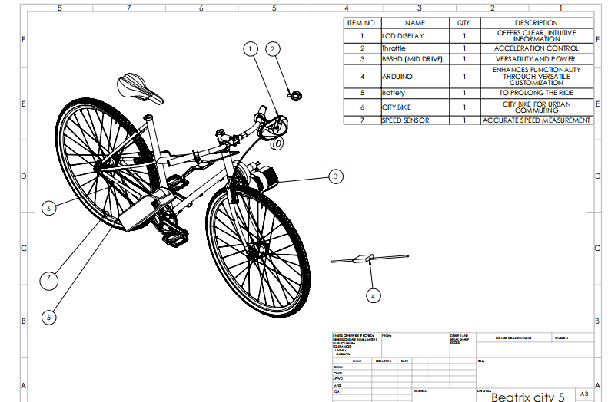

Fig. 1 Final design
E-bike final design in Fig. 1 is a standard bicycle, then adds various electrical components, such as a motor, a battery, display, and a controller, all of which are smoothly integrated into the design [1]. These components are the foundation of all electric bicycles on the market. Electric bicycles, or E-bikes, are bicycles equipped with an electric motor to aid with propulsion, allowing you to reach higher speeds more easily. They are one of the most recent technological advances in transportation, and they offer a unique potential to lower your carbon impact.
  - Fabrication
The fabrication process is a crucial phase in the development of the e-bike conversion kit with a fingerprint-based security system. The fabrication process involves several processes such as the measurement process to make the battery casing. Next, print the battery casing using a 3D printer. Material selection was vital, as it needed to balance durability, weight, and thermal properties [15]. After choosing a suitable material, the 3D printing process was carefully planned, including setting the printer parameters such as layer height and infill density.
The selection of material for the battery case was a critical step to ensure the final product met the required performance standards. The material needed to strike a balance between durability, lightweight properties, and adequate thermal resistance to safeguard the battery under various operating conditions. After evaluating several options, a high-performance thermoplastic was chosen due to its strength-to-weight ratio, impact resistance, and ability to withstand moderate heat generated by the battery during use. This material also provided compatibility with the 3D printer used, ensuring smooth and precise fabrication. Once selected, the 3D printing process was meticulously planned, including setting optimal printer parameters such as layer height, infill density, and print speed to achieve a robust and reliable battery case.
The integration of the fingerprint security system was another critical part of the project. Fingerprint security system This involved designing and fabricating a secure and accessible mount for the fingerprint sensor on the e-bike. The wiring and connectivity processes were meticulously planned to ensure seamless integration with the bike's electronic system. This included ensuring a stable power supply and reliable data communication with the motor controller.
Lastly, the assembly of the conversion kit involved integrating all the components, including the motor, battery, controller, and security system. Mechanical assembly steps were taken to ensure that all parts fit together securely and function as intended. Electrical connections were meticulously wired, ensuring safety and reliability through careful soldering, insulation, and connector selection. Fig. 2 shows all the fabrication processed.

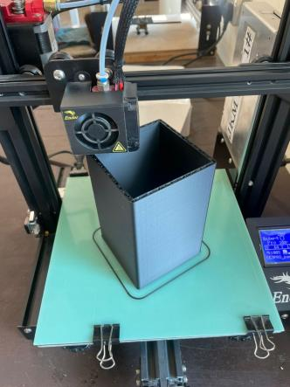 | 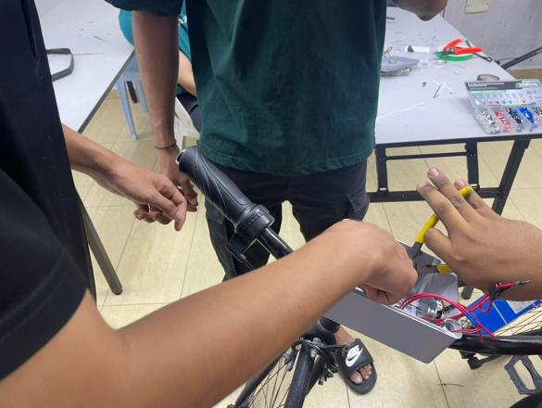 | 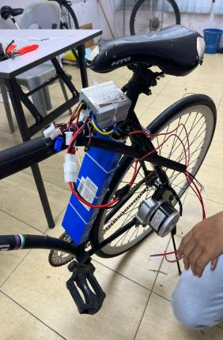
(a) | (b) | (c)
Fig. 2 Fabrication process (a) Printing battery casing; (b) Installation fingerprint system; (c) Mechanical Assembly
- Result and Discussion
E-Bike Conversion Kits will be tested with several types of tests to see and assess the capabilities of the machine.
  - E-Bike Conversion Kit Working Principles
The core of the system is the motor, which attaches to your bike's frame and provides electric assistance when you pedal. The motor, typically a hub motor mounted in the rear wheel, acts as the electric engine of your e-bike. A controller receives signals from various sensors and regulates the motor's power output based on your input and riding conditions. While a battery provides electricity to the motor. Also have a separate thumb throttle for manual power control.
A fingerprint sensor is typically mounted near the handlebars. When the user powers on the system, it prompts the user to scan your fingerprint. Upon successful recognition, the system unlocks, allowing the user to use the electric assist features. The fingerprint scanner communicates wirelessly with the controller. Once it verifies the user fingerprint, it sends a signal to the controller, enabling power delivery to the motor. With PCB Board, it can save 8 fingerprints, which is 8 users can be used. Fingerprint recognition offers a more secure alternative to traditional key-based systems, eliminating the risk of misplaced keys.
Incorporating a fingerprint recognition system into an e-bike conversion kit enhances security and personalizes your riding experience. It offers a convenient, keyless solution for activating your e-bike while deterring potential theft. With its user-friendly interface and sophisticated power management, a fingerprint-enabled e-bike conversion kit can transform your everyday commute or recreational rides into a smooth, secure, and enjoyable experience.
  - Data Collection
To evaluate the motor speed, tests were conducted at different load levels such as no load, medium load, and high load. These loads correspond to flat terrain riding, moderate uphill riding, and steep uphill riding, respectively. The motor speed (in km/h), torque (in Nm), and power consumption (in watts) are measured using appropriate sensors and data acquisition systems.
Table 1 Motor speed based on load level
Load level | No load | Medium load | High load
Motor speed (km/h) | 20 | 14 | 12
Time (s) | 18.01 | 25.71 | 30.03
Torque (Nm) | 0.3 | 0.1 | 1.7
Output power (W) | 5.56 | 12.97 | 18.87
Angular velocity (rad/s) | 18.53 | 12.97 | 11.10
Distance (m) | 100 | 100 | 100

Table 1 shows the data for motor speed based on load level. Motor speed decreases as the load increases. At no load, the motor reaches a speed of 20 km/h. However, with a medium load, the speed drops to 14 km/h, and further decreases to 12 km/h under high load conditions. This trend indicates that the motor's ability to maintain high speeds is inversely related to the load it carries.
The time required to travel a fixed distance of 100 meters increases with the load. With no load, the e-bike covers this distance in 18.01 seconds. Under medium load, the time extends to 25.71 seconds, and it further increases to 30.03 seconds with a high load. This increase in travel time under heavier loads demonstrates the additional strain on the motor, reducing its efficiency in terms of speed.
The output power of the motor rises with increasing load levels. At no load, the motor produces an output power of 5.56 W. This output is more than doubles to 12.97 W under medium load and reaches 18.87 W with high load. This escalation in power output is necessary to overcome the increased resistance and maintain movement under heavier loads.
Our e-bike conversion kit's motor demonstrates a clear relationship between load levels and its performance metrics. As the load increases, both motor speed and angular velocity decrease, while the time to travel a fixed distance increase. Conversely, the output power of the motor increases with higher loads to compensate for the additional effort required to maintain movement.
  - Distance VS Time Graph
Compares the speed performance of a bicycle equipped with the conversion kit to standard bicycles under flat terrain conditions. The objective is to evaluate the time efficiency of the e-bike conversion kit over various distances, specifically 100 meters, 150 meters, and 200 meters. These comparisons provide insight into the advantages of using the e-bike conversion kit in terms of travel time savings on flat terrain.
To conduct this comparison, a series of timed trials were performed with both the e-bike and a standard bicycle. The tests were conducted on a flat, straight path to ensure consistent conditions. Both bicycles were ridden by the same rider to minimize variations due to different riding styles or fitness levels. The trials were repeated three times for each distance to ensure accuracy and reliability of the data. Fig. 3 shows the different time when using an e-bike conversion kit and normal bike. The red line is for normal bikes while the orange line is for e-bike.
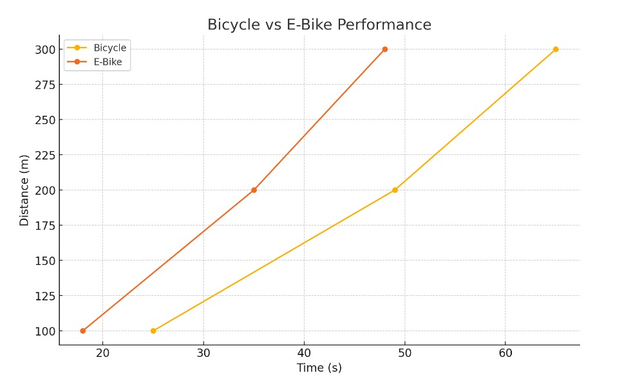
Fig. 3 Graph Time vs Distance
The results clearly indicate that the e-bike equipped with the conversion kit significantly outperforms the standard bicycle in terms of speed on flat terrain. This consistent performance improvement highlights the efficiency and time-saving benefits of using an e-bike with the conversion kit for short to moderate distances on flat terrain. The test revealed that the e-bike equipped with the conversion kit demonstrated a significantly higher velocity compared to the standard bicycle, particularly on flat terrain. It is likely that the velocities were measured at a constant speed to ensure fair and consistent comparison between the two bicycles. This performance difference can be attributed to the enhanced mechanical assistance provided by the conversion kit, which reduces the effort required to maintain or increase speed, thus improving efficiency and saving time for short to moderate distances.
- Conclusion
The E-Bike Conversion Kit project successfully addressed the key objectives outlined at the project's inception. The development of a secure fingerprint recognition system enhances the security of the e-bike, making it a reliable option for university students. This innovation is crucial in preventing theft and providing peace of mind to users. Additionally, the cost effective and energy efficient electric motor system was implemented, which is suitable for short distance travel withing a campus or urban environment.
The project's scope was meticulously adhered to, ensuring that the e-bike conversion kit is easily installable on a variety of city bike models. This adaptability makes the product accessible to a wider range of users. The focus on sustainability was also achieved, providing an eco-friendly alternative to traditional gasoline-powered vehicles, thus contributing to reduced air pollution and promoting a greener campus environment.
Future iterations of the E-Bike Conversion Kit should prioritize expanding its range and efficiency, aiming to exceed the current 5 km per charge. This can be achieved by incorporating advanced battery technologies and optimizing motor efficiency. Enhancing the user interface is also crucial. Integrating a small digital display connected to the Arduino system will provide real-time data on battery status, distance traveled, and other important metrics, greatly improving the user experience.
Robust testing and feedback are essential for refining the product. Conducting extensive field tests across various terrains and user demographics will provide valuable insights for improvement, ensuring the kit meets diverse user needs. A marketing and education campaign is important for raising awareness and driving adoption, especially in university settings where the benefits of e-bikes can be effectively communicated. Collaborating with universities to create pilot programs will offer real-world data and user experiences, helping to refine the product further. These partnerships can also open up a significant market for the conversion kits, benefiting both the universities and the product's development.
Acknowledgement
The authors would also like to thank the Centre for Diploma Studies, Universiti Tun Hussein Onn Malaysia for its facility and its support.
Conflict of Interest
Authors declare that there is no conflict of interests regarding the publication of the paper.
Author Contribution
The authors confirm contribution to the paper as follows: study conception and design: Mohd Hadri Mohamed Nor, Muhammad Ammar Haziq Muhammad Akmal, Shakir Aiman Sayfulidham, Darshan a/l Chandran; data collection: Muhammad Ammar Haziq Muhammad Akmal, Shakir Aiman Sayfulidham, Darshan a/l Chandran; analysis and interpretation of results: Mohd Hadri Mohamed Nor, Muhammad Ammar Haziq Muhammad Akmal, Shakir Aiman Sayfulidham, Darshan a/l Chandran; draft manuscript preparation: Mohd Hadri Mohamed Nor, Muhammad Ammar Haziq Muhammad Akmal, Shakir Aiman Sayfulidham, Darshan a/l Chandran. All authors reviewed the results and approved the final version of the manuscript
References
[1] G. Kilgore. (2024). 8 top e-bike conversion kits (mid drive vs. rear hub vs. front wheel),” Eco-Friendly Natural Products. [Online]. Available: https://8billiontrees.com/eco-friendly-natural-products/ebike-conversion-kits/.
[2] G. U. Maheswari, B. Vimalan, K. Vimalnath, K. W. Jefferson, and N. Vignesh (2020). Cost Effective Conversion of Electric Bike [Online]. Available: www.irjet.net
[3] Evelo. (2024). Intro to electric bikes - what they are & how they work [Online]. Available: https://evelo.com/pages/electric-bikes-101.
[4] Alter, L. (2020). Study Shows How E-Bikes Can Dramatically Reduce CO2 Emissions from Transportation [Online], Available: https://www.treehugger.com/study-shows-how-e-bikes-can-dramatically-reduce-co2-emissions-transportation-4848048.
[5] Innovatrics. (2024). “What is fingerprint?” [Online]. Available: https://www.innovatrics.com/fingerprint-technology.
[6] OMRON Industrial Automation. (2024). Technical explanation for RFID systems [Online]. Available: https://www.ia.omron.com/support/guide/47/introduction.html.
[7] K. Manral. (2024). RFID: What are its advantages and disadvantages?” [Online]. Available: https://blog.se.com/industry/machine-and-process-management/2021/06/20/rifd-what-are-its-advantages-and-disadvantages/.
[8] K. Eberl. (2024). How to choose the best e-bike conversion kit for your bike. Family Handyman [Online]. Available: https://www.familyhandyman.com/article/e-bike-conversion-kit/.
[9] EbikeSchool. (2024) Electric bicycle batteries: lithium vs. lead acid batteries. [Online]. Available: https://www.ebikeschool.com/electric-bicycle-batteries-lithium-vs-lead-acidbatteries/.
[10] O. Bolton Jr., “Electrical bicycle,” U.S. Patent 552271A, Dec 31, 1985
[11] D. Cavallari. (2002). Do I need a hub drive or a mid-drive motor? [Online]. Available: https://www.cyclevolta.com/story/ebike-basics/hub-drive-vs-mid-drive-e-bike-motor-comparisonanalysis/.
[12] Shengyi. (2024). What are the advantages of a mid-drive motor? [Online]. Available: https://www.syimotor.com/what-are-the-advantages-of-a-mid-drive-motor.html.
[13] The E-bike Specialist. (2024). Are e-bike conversion kits worth it? Perth and Fremantle's best bike specialist,” [Online]. Available: https://www.theebikespecialist.com.au/are-ebike-conversion-kits-worth-it/.
[14] J. D. Goodman. (2024). An electric boost for bicyclists [Online]. Available: https://www.nytimes.com/2010/02/01/business/global/01ebike.html.
[15] Bambu Lab Community. (2024). Best filament for a battery enclosure? [Online]. Available: https://forum.bambulab.com/t/best-filament-for-a-battery-enclosure/56299?page=2.

