Design a Quad Band Monopole Antenna for RFID, WLAN and WiMAX Application

Muhammad Mustakeen Mohd Famee¹, Samihah Abdullah^{1*}, Shabinar Abdul Hamid¹, Nor Shahanim Mohamad Hadis¹, Solahuddin Yusuf Fadhullah²

¹School of Electrical Engineering, College of Engineering,
Universiti Teknologi MARA, Cawangan Pulau Pinang, MALAYSIA

²School of Engineering and Technology,
INTI International College, Pulau Pinang, MALAYSIA

*Corresponding Author

DOI: https://doi.org/10.30880/jeva.2022.03.01.002
Received 30 August 2021; Accepted 16 December 2021; Available online 30 June 2022
Abstract: A small, compact size antenna with multiband frequency function has become a high demand in this modern era. This demand for this multiband frequency antenna increases throughout the year due to evolution of modern technologies that in need of small devices with multi functions. In wireless communication system, a microstrip patch antenna was introduced to fulfil the requirement of the modern technologies. The antenna is built with small sizes with the ability to operate multiband frequencies. A quad-band monopole antenna is introduced in this paper. The purpose of this project is to design an antenna that has the capability of operating four different types of frequencies which are 915 MHz for RFID application, 2.4 GHz and 5.8 GHz for WLAN and 3.5 GHz for WiMAX application. The antenna is designed and simulated by using a Computer Simulation Technology (CST) software. The results obtained from the simulation process was analysed and recorded. The antenna is designed to have eight symmetrical rectangular strip lines microstrip patch. The substrate used for this antenna is FR-4 that has the permittivity of 4.3 and the dimension of 20 mm x 28 mm x 1.6 mm. A ground plane is constructed at the back of the antenna and it is fed with 50Ω microstrip line. The designing process involve three stages of antenna modification which are antenna 1 (four strip lines), antenna 2 (six strip lines) and antenna 3 (eight strip lines). The antenna managed to achieve quad band frequency in the simulation and has omni-directional radiation pattern. However, two of the operating frequency are for different frequency application. The new frequency application is 1.5 GHz for Global Positioning System (GSP) and 2.9 GHz for Third Generation (3G) application. Therefore, the results proved that the antenna designed can be used for GPS and 3G application.

Keywords: Microstrip, rectangular folded strip line antenna, quad-band

- Introduction
An antenna is a communication device that are capable of transmitting and receiving information through spaces and it also appears to be one of the most important electrical devices. In recent years, the demand for antenna that can operate triple or multiband frequency has increased due to the need for an antenna that combine more than one communication standards in one operating system [7]. This is because the antenna has to be portable to suit a modern personal communication system [11]. Therefore, a microstrip patch antenna was created to fulfill the needs of modern communication system and it was design to has a simple structure, compact size and easy to combine with the circuit [11].
The planar monopole antenna appears to be self-complimentary radiating structures that provide frequency independent performance over wide operating bandwidth [1]. Antennas that are capable for providing frequency independence have been developed for applications with various polarization requirements [1]. In addition, antenna with frequency independent characteristic includes helix, bowtie antennas dipole and certain log-periodic antennas. Besides, the planar monopole antenna is widely used due to its compact shape factor and generally good performance.
Nowadays, these communication standards such as Radio Frequency Identification (RFID), Wireless Local Area Network (WLAN), the fifth-generation (5G) cellular network, Bluetooth-enabled devices and Worldwide Interoperability for Microwave Access (WiMAX) are accessed daily by people over the world [13]. Thus, the demand for creating multiband antenna increases due to increase in user that access these communication standards.
There are three types of multiband antenna that were built with compact size which is the monopole antenna, slot antenna and patch antenna [1]. These antennas have one thing in common that is to obtain multiband frequency [1]. There are several techniques can be used to obtained multiband frequency such as applying slot technique, notch loading [8], using parasitic and fractal element [9], electromagnetic bandgap (EBG) [15], and circular defected ground plane structures (DGS) [1].
Other than that, the concept of omnidirectional radiation pattern is used in making the multiband frequency antenna. By proposing this concept, the designed antenna will fulfill the wireless communication system requirements. Omnidirectional antenna has the capability to radiates signal equally to all direction [1]. This particular type of antenna is commonly used in radio frequency wireless devices such as the smartphones and wireless routers [1].
- Literature Review
Multiple researches and reviews on previous studies that are related to the project were made to have a much better understanding on the microstrip patch antenna and its other properties. The review of the previous study is crucial in order to see the performance of the antenna and find a room to improve the antenna design. There are several topics that are reviewed which is the microstrip patch antenna, the folded strip antenna, feeding technique and the quad band application.
A microstrip patch antenna is a type of antenna that is commonly used in microwave frequency range and they are often used in millimeter-wave frequency range [3]. It is also known as patch antenna since it consists of metallic patch of metal on top of the grounded dielectric substrate of thickness h, with relative permittivity 𝜀𝑟 and relative permeability 𝜇𝑟 [3]. The shape of the metallic patch can be in various shapes such as rectangular, triangular, square etc [3]. A resonant cavity is created by the metallic patch where the patch is the top of the cavity [3]. Meanwhile, the ground plane is the bottom cavity and the edges of the patch creates the side cavity [3]. A strong electric field generates on the patch surface when the antenna is stimulated at a certain frequency and it is basically z-directed and independent of the z-coordinates [3] The proposed antenna of this project is known as the folded strip antenna. A folded strip antenna is an antenna that is design with a folded strip line. According to several previous studies, this design is applied to both monopole and dipole antenna [1] [5]. Besides, the proposed antenna is one of the antennas that is capable of operating multi-band frequency. The folded strip line design was inspired by many other microstrip antenna [1]. One of the applications of folded strip line design can be seen in the meandered fork-shaped monopole antenna design [5]. This design was found in the paper titled “Design of Compact Dual-Band and Tri-Band Microstrip Patch Antennas”. Another interesting feature of this antenna design is that they are easy to design, fabricate and has smaller dimensions [5].
Other than the patch design, the feed line is one of the important components the antenna. A feed line is a cable that connects the antenna to the transmitter, receiver or transceiver in a wireless communication system [16]. It feeds radio signal from an antenna to a transmitter or receiver [16]. The electrical energy flows from the source to the antenna through the feed line [15]. The feed line has various techniques and the most popular feed techniques are the coaxial cable, aperture coupling and microstrip line [4]. For this project, the technique that is used to feed the antenna is the microstrip line. The advantage of this feed technique is the feed line and the microstrip patch can be etched on the same substrate [4]. Once the design is complete, the waveguide port is generated at the beginning of the feed line. The waveguide port is needed to feed the microstrip line. For this antenna, a rectangular waveguide is used. A rectangular waveguide is known as one of the earliest transmission lines [6]. It is used in many applications [6]. Components such as isolators, detectors, and attenuators used a rectangular waveguide and these components are in the frequency range from 1 GHz to above 220 GHz [6].
On the other hand, the proposed antenna is designed to operate four frequency band or quad-band for three different application which is the Radio Frequency Identification (RFID), Wireless Local Area Network (WLAN) and Worldwide Interoperability for Microwave access (WiMAX). The multi-band frequency can be achieved by several techniques. Based on the previous papers, the techniques that can be used to design the antenna is by slotting the patch of the antenna and notch loading [8], using parasitic and fractal elements [9], shorting pin [13] and adding lumped elements [10] [14]. For this antenna, a slotting patch technique is applied. This technique is applied by cutting out some areas in the on the patch of the antenna in a specific pattern or shape in order to achieve the desired resonant frequency.
In this paper, there are three different sections to be included which is the methodology, the results and discussion and finally the conclusion for this project. The methodology section has two parts which is the design procedure and the feeding technique. The design procedure includes all the methods and the process from the beginning to the end of completing this project. It shows the flowchart for the whole process of the project, all the details about the specification of the proposed antenna such as the types of material used for the substrate and the patch, the antenna parameters and the antenna design. Meanwhile, the results and discussion section include all the results obtained from the CST simulation and each of the results are observed and analyzed. The things that are stated in the results are the s-parameter, the voltage standing wave ratio (VSWR), the radiation pattern of the antenna and finally the gain and the bandwidth. In the final section which is the conclusion, all the findings and data analyzed from the obtained results are concluded. There are some recommendations are included as well to improvise the antenna for the future work.
- Methodology
This paper is executed to study a monopole antenna with folded strip lines. The monopole antenna is design to operate at four different types of frequencies which is for Radio Frequency Identifications (RFID), Wireless Local Area Network (WLAN) and Worldwide Interoperability for Microwave Access (WiMAX). Besides, this antenna is design to have eight symmetrical strip lines.
A lot of research had been done by the previous researchers to study about the design of a folded strip lines antenna. So, to execute this project, a few papers from the previous researches were used as a reference to study and design the antenna. The aspects that are included in the design are the microstrip patch design, the feedline, the substrate and the waveguide port. All of these aspects are important in order to design an antenna and to get the desired result. Therefore, these aspects need to be study and understand before designing the antenna.
A quad-band monopole antenna with rectangular folded strip line is designed by a software called the CST studio Suite. The CST stands for Computer Simulation Technology. A waveguide port is used to feed the patch antenna for the simulation process. The dimension of the waveguide port needs to have a suitable measurement in order to obtain the desired resonant frequencies. This condition is also applied for designing the patch and the feedline of the antenna. This is because the measurement of the mentioned aspects played a crucial role to successfully get the results.
In addition, the return loss of the patch antenna is used to determined credibility of the resonant frequencies obtain from the simulation result. So, the value of the return loss must be lower than -10 dB for the resonant frequencies obtain from the simulation result to be acceptable. However, the simulation process needs to be reconstructed if the value of the return loss is higher than -10 dB. Thus, the geometry of the microstrip patch antenna such as the dimension of the patch, feedline and the waveguide port need to be revise and reconstructed for the results to be adequate and acceptable.
- Design Procedure
Figure 1 shows the flowchart of the whole process that took to design the microstrip antenna. The design process only involved the CST software simulation process. This flowchart is needed to ensure each working step can be executed smoothly and has a clear purpose.
The first step of this project is to gather and study several research papers that are related to the rectangular strip line antenna and gain much information about the antenna design. Those research papers and journals were used as a reference before designing the proposed antenna. Then, the next step is proceeded after gaining adequate information and having an understanding about the antenna design. The dimension of the antenna was constructed according to the calculated theory in the paper.
Next, the simulation of the proposed antenna is proceeded after the antenna is fully constructed. If the resonant frequency has the return loss value that is lower than -10dB, the dimension of the antenna needs to be recalculated and readjusted until gets lower value.
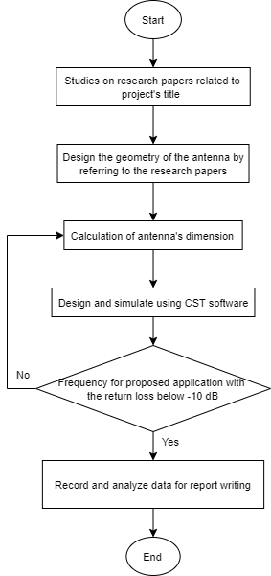
Fig. 1 - Flowchart of the whole process
The proposed quad band monopole antenna was simulated to obtain multiple operating frequencies which is 915 MHz (RFID), 2.4 GHz and 5.8 GHz (WLAN) and 3.5 GHz (WiMAX). The antenna was designed to have a set of specification. The specification of the antenna can be seen in table 1.
Table 1 - Microstrip antenna specification
Operating Frequency | 915 MHz, 2.4 GHz, 3.5 GHz & 5.8 GHz
Return Loss | Lower than -10 dB
Voltage Standing Wave Ratio (VSWR) | Lower than 2
Radiation Pattern | Omni-directional
Line Impedance | 50Ω

Meanwhile the material properties of the antenna are shown in table 2. The material that was used for the substrate and the patch is FR-4 and copper respectively. The dimension of the proposed antenna is 20mm x 28mm which has the thickness of 1.6mm and the permittivity of 4.3. The FR-4 was chosen as the antenna’s substrate since it is low cost and it can perform well in any environment condition which explains why the substrate is commonly used in the industry [10].
Table 2 - Material properties of the antenna
Substrate Material | FR-4
Patch Material | Copper
Dielectric Constant | 4.3
Substrate Thickness | 1.6mm
Patch Thickness | 0.035mm

Table 3 shows the parameters of the proposed antenna and its dimension. The proposed antenna was built with these parameters to obtain quad-band frequency application. Besides, this parameter helps the antenna to achieve omni-directional radiation pattern and voltage standing wave ratio (VSWR) that is lower than 2.
Table 3 - Parameters of the antenna
Part | Parameter | Value (mm)
Width Substrate | Ws | 20
Length Substrate | Ls | 28
Width Patch | Wp | 16
Length Patch | Lp | 28
Width Ground | Wg | 20
Length Ground | Lg | 3
Thickness Substrate | Ts | 1.6
Patch Height | Ht | 0.035
Width Feed | Wf | 2
Length Feed | Lf | 8
Strip Line (Width) | W1 | 0.6
Strip Line (Length) | L1 | 16.8
Spaces Between Strip Line (Width) | W2 | 0.8
Spaces Between Strip Line (Length 1) | L2 | 1
Spaces Between Strip Line (Length 2) | L3 | 1.25
Feed Slot (Width) | Wa | 1
Feed Slot (Length) | La | 4
Small Feedline (Width) | Wb | 0.3
Small Feedline (Length) | Lb | 3.2

Figure 2 and figure 3 shows all the designs of the proposed microstrip. The antenna is labeled with the parameters as well. The antenna has three stages of designing where stage one antenna has four (4) strip lines, stage two has six (6) strip lines and stage three has eight (8) strip lines. This design process is needed in order to obtain quad band frequency. The antenna design was inspired from a previous paper entitled “A Small Quad-Band Monopole Antenna with Folded Strip Lines for WLAN/WiMAX and ITU applications” [1].
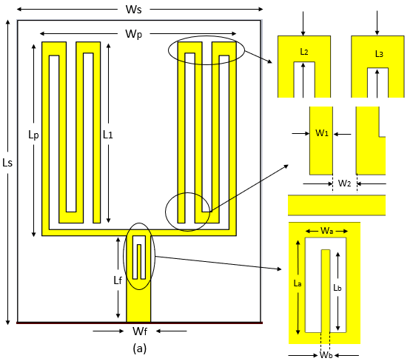
Fig. 2 - Front view of antenna
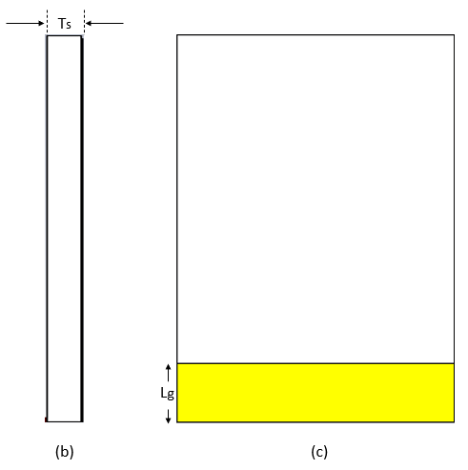
Fig. 3 - (b) side view; (c) back view

The proposed antenna had three stages of antenna design. The antenna design in the first stage was designed to have four rectangular strip lines and six rectangular strip lines in the second stage. For the third stage, the antenna was designed to have eight rectangular strip lines. Besides, all of these strip lines need to be symmetrical. The proposed antenna needs to undergo three stages of designing to ensure that the resonant frequency obtained from the simulation is valid and acceptable which has the return loss that is lower than -10 dB. in the first and the second stage, the antenna can achieve any resonant frequency values. But in the third stage, the proposed antenna supposedly able to achieve the proposed frequency band which is for RFID, WLAN and WiMAX application. Figure 4 shows the design of antenna for every stage of modification.
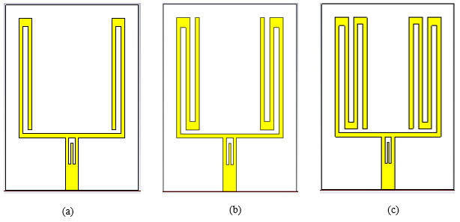
Fig. 4 - (a) antenna 1; (b) antenna 2; (c) antenna 3
- Feeding Technique
The feeding technique that was used to feed the antenna is the microstrip line feed. This microstrip line feed is one of the commonly used method to feed an antenna. In the simulation, a waveguide port was generated at the beginning of the feedline and its dimension was calculated by using the port solver. In addition, the feedline was fed with the line impedance of 50Ω. Figure 5 shows the waveguide port that generated to feed the microstrip antenna.
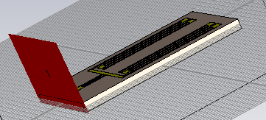
Fig. 5 - Waveguide port of the antenna

- Results and Discussion

- S-parameter
In this section, the s-parameter of this antenna will be compared with the reference paper [1] to see the difference between the frequency application. This is because the proposed antenna was designed based on reference paper [1]. The purpose of comparing the frequencies is to see if the value of the frequency is acceptable or invalid. The proposed antenna was designed to have the capability to operate multiple frequency band. The frequency that was proposed for this antenna is 915 MHz, 2.4 GHz, 5.8 GHz and 3.5 GHz. In addition, these frequencies must have the return loss that is below than -10 dB for their value to be valid and accepted. However, the frequencies obtained from the simulation is different from the proposed values. According to the simulation results, the resonant frequencies that generated are 1.53 GHz, 2.41 GHz, 2.9 GHz and 3.545 GHz and has the return loss of -20.71 dB, -22.129 dB, -45.525 dB and -21.619 dB respectively. So, there are two frequencies that has different frequency band which is 1.53 GHz and 2.9 GHz. Figure 6 shows the s-parameter for the antenna.
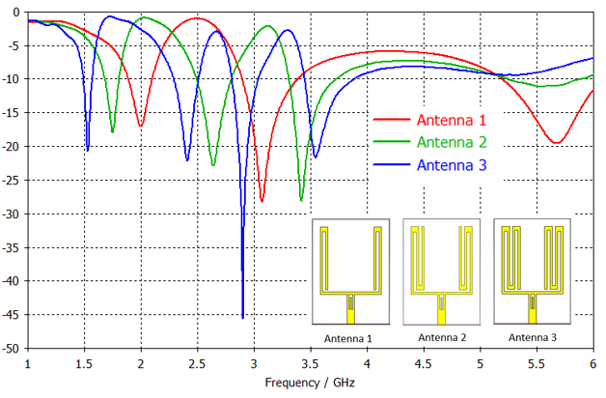
Fig. 6 - Antenna S-parameter
Table 4 shows the comparison of the s-parameter between the reference antenna, proposed value and the simulation results. The reference antenna is for WLAN/WiMAX and ITU application which has the frequency value of 2.4 GHz, 3.5 GHz, 4.3 GHz and 5.5 GHz. The frequency 915 MHz and 5.8 GHz are for RFID and WLAN application but the new frequencies obtained which is 1.53 GHz and 2.9 GHz has different application.
Table 4 - Comparison of s-parameter (all)
Reference antenna (GHz) [1] | Proposed frequency (GHz) | Simulation frequency (GHz)
2.4 | 0.915 | 1.53
3.5 | 2.4 | 2.41
4.3 | 3.5 | 2.9
5.5 | 5.8 | 3.545

As shown in the table above, the reference antenna has different frequency application compared to this project’s antenna. Besides, it was used as a reference to build the proposed antenna. However, the antenna in the simulation obtained different frequency application even it manages to operate four frequency bands. Two of the frequency band matches the proposed frequency while the other two frequency have different values. The antenna achieves these frequency bands in the simulation due to its own dimension. The antenna had undergone multiple dimension calculations and readjustments until it gets the final results. The presented frequencies in the table above are the best values that this antenna can achieve. This is because the final antenna dimension manages to help the antenna to obtain four frequency bands even two of it has different frequency applications. Table 5 shows the comparison of frequency application between the reference antenna, proposed frequency and simulation frequency.
Table 5 - Frequency application comparison between antenna
Antenna | Application | Frequency (GHz)
Reference [1] | WLAN/WiMAX/ITU | 2.4/3.5/4.3/5.5
Proposed | RFID/WLAN/WiMAX | 0.915/2.4/3.5/5.8
Simulation | GPS/WLAN/3G/WiMAX | 1.53/2.41/2.9/3.545

Table 6 shows the comparison of s-parameter for frequency 2.4 GHz (WLAN) and 3.5 GHz (WiMAX). In the simulation, the 2.4 GHz and 3.5 GHz frequency shifted 0.42% and 1.29% to the right respectively. Since the percentage difference of the frequency has small value, the simulation frequency still stays in the proposed frequency range. Therefore, the simulation frequency 2.41 GHz and 3.545 GHz are acceptable as WLAN and WiMAX application.
Table 6 - comparison of s-parameter (2.4 GHz & 3.5 GHz)
Proposed Frequency (GHz) | Simulation Frequency (GHz) | Difference (%)
2.4 | 2.41 | 0.42
3.5 | 3.545 | 1.29

The new resonant frequency which is 1.53 GHz and 2.9 GHz obtained in the simulation has different application. Based on several previous studies, the frequency 1.575 GHz is used for Global Positioning System (GPS) [17]. Therefore, 1.53 GHz is suitable to be considered as GPS application since they have a small difference in value. Meanwhile, 2.9 GHz is used as Third Generation (3G) application in the previous study [18]. Table 7 shows the comparison between the new resonant frequency in simulation with their original values.
Table 7 - Comparison of S-Parameter (New frequency)
New frequency (GHz) | Simulation frequency (GHz) | Difference (%)
1.575 | 1.53 | 2.86
2.9 | 2.9 | 0

- Voltage Standing Wave Ratio (VSWR)
Voltage Standing Wave Ratio (VSWR) is one of the important in designing antenna. It is defined as the ratio of maximum amplitude to minimum amplitude of a standing wave. It can be considered as a method to see how efficiently the radio frequency power is transmitted from the power source into the load through transmission line. VSWR has the range from 1 to infinity. However, the VSWR value that is below than 2 is consider suitable for most antenna application. The smaller the value, the higher power delivered to the antenna.
Figure 7 shows the VSWR value for all resonant frequencies in the simulation. The VSWR for 1.53 GHz is 1.2031, 2.41 GHz is 1.1698, 2.9 GHz is 1.0106 and 3.545 GHz is 1.181. Therefore, all frequencies obtain in the simulation is valid and accepted since all of them has VSWR value that is lower than 2.
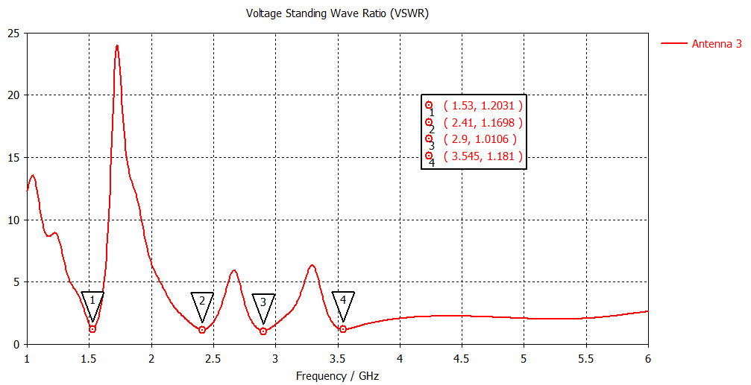

Fig. 7 - Antenna VSWR
- Radiation Pattern
The radiation pattern of this antenna was generated during the simulation process. Every resonant frequency has their own radiation pattern. The results show that the radiation pattern for this antenna is omni-directional. So, the antenna is capable to radiates signal in any direction. In this section, the 2D (E-Plane & H-plane) radiation pattern is presented.
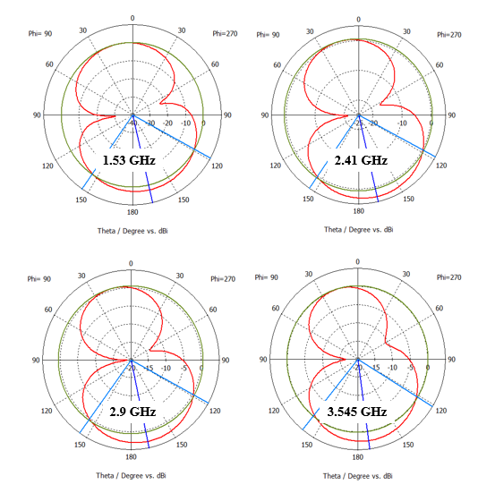
Fig. 8 - E-Plane for each frequency
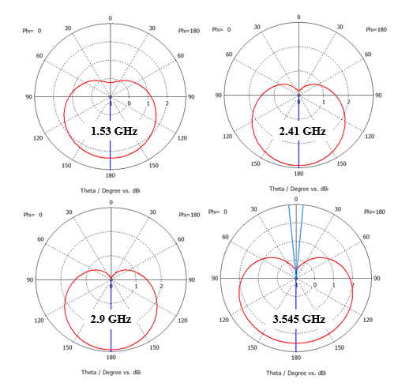
Fig. 9 - H-Plane for each frequency
- Gains And Bandwidth
The gains and the bandwidth of the antenna is observed as well. Since the proposed antenna was designed to operate quad band frequency, so there will be four gains and bandwidth as well. According to the simulation, the gain and the bandwidth for frequency 1.53 GHz is -4.8978 dB and 77.7 MHz respectively. For frequency 2.41 GHz (WLAN), the gains and the bandwidth are -2.3748 dB and 217.4 MHz. Meanwhile, the resonant frequency 2.9 GHz has -1.9238 dB for gain and has 233.3 MHz bandwidth. The fourth resonant frequency which is 3.545 GHz (WiMAX) has -0.65634 dB and 434.4 MHz for gain and bandwidth respectively. Table 6 shows the gains and the bandwidth for each resonant frequency of the antenna.
Table 8 - Gains and bandwidth of antenna
Frequency (GHz) | Gains (dB) | Bandwidth (MHz)
1.53 | -4.8978 | 77.7
2.41 | -2.3748 | 217.4
2.9 | -1.9238 | 233.3
3.545 | -0.65634 | 434.4

- Parametric Research
In this section, the study of antenna parameters is presented. The purpose of this study is to observe and analyze how each part of the antenna can affect the results. This study is conducted by varying the size of the antenna parts to see how it affect a certain result. The parts of the antenna that are usually affected the results are the patch of the antenna, the feedline, substrate and the design of the patch such as the size or the number of the rectangular strip lines. By conducting this study, the results can be properly analyzed. Besides, it can be seen which part of the antenna had most effect towards the simulation results. It could be either the gains, bandwidth or the s-parameter of the antenna. In addition, the proposed antenna had gone through this study to obtained the current results.
- Rectangular Strip Lines
The rectangular strip lines are the patch design for the proposed antenna. The antenna consists of eight (8) symmetrical rectangular folded strip lines all together. The number and the size of the strip lines affect the resonant frequency in the s-parameter result. In this section, the effect of the rectangular strip lines towards the s-parameter is presented. However, the effect of the rectangular strip lines number towards the s-parameter had been stated in the antenna results s-parameter section. It shows every stage of the antenna design and their resonant frequencies. So, this section will show the effect of the rectangular strip line size towards the s-parameters. There will be two parameters to be tested which is the strip line width, W1 and the spaces between the strip line (width, W2). The figure below shows the dimension for these two parameters.
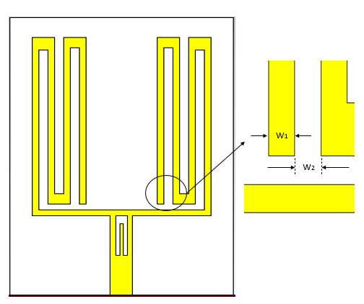
Fig. 10 - Strip line dimension of antenna
For the first design, the value for both W1 and W2 was set as 1 mm. Based on the simulation result, the antenna managed to obtain four resonant frequencies which is 1.665 GHz, 2.515 GHz, 3 GHz and 3.575 GHz. The return loss value of this antenna is -19.971 dB, -20.8 dB, -37.677 dB and -22.056 dB respectively. So, the resonant frequency value is valid since the return loss is lower than -10 dB. However, the values obtained are not as the one that was proposed in this project. Table 9 shows the s-parameter for this antenna design.
Table 9 - S-parameter and antenna gain (strip line dimension: W1=W2=1 mm)
Resonant frequency (GHz) | Return loss (dB) | Gain
1.665 | -19.971 | -3.0984
2.515 | -20.8 | -1.9468
3 | -37.677 | -1.62
3.575 | -22.056 | -0.56349

Then, the dimension of W1 and W2 was change to another value. This is because the antenna cannot achieve the desired frequency band by using the value before. The value of W1 and W2 changed to 0.8 mm after numerous considerations. According to the simulation result, the resonant 1.605 GHz, 2.47 GHz, 2.95 GHz and 3.57 GHz and their return loss are -20.034 dB, -20.737 dB, -42.782 dB and -21.903 dB respectively. The results for this antenna design are shown in the Table 10 below.
Table 10 - S-parameter and antenna gain (strip line dimension: W1=W2=0.8 mm)
Resonant frequency (GHz) | Return loss (dB) | Gain
1.605 | -20.034 | -4.3104
2.47 | -20.737 | -2.0617
2.95 | -42.782 | -1.7769
3.57 | -21.903 | -0.64851

The results shown in Table 4.5 and Table 4.6 had proved that these values use for W1 and W2 did not manage to help the antenna to achieve the desired resonant frequency even the antenna manage to get four frequency bands. Therefore, the proposed antenna dimension is the most suitable since it helps the antenna to obtain the desired resonant frequencies. Figure below shows the s-parameter comparison between three values of W1 and W2.
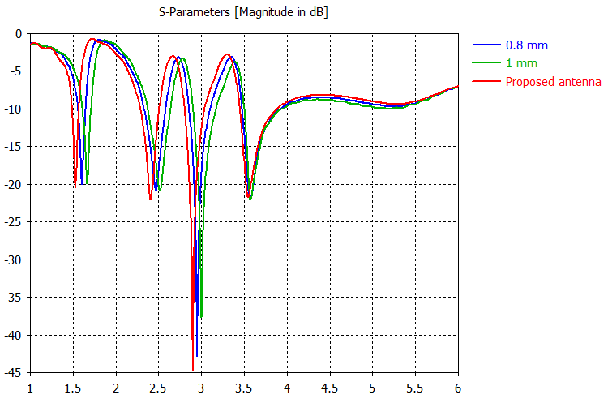
Fig. 11 - S-parameter comparison for dimension W1 and W2
- Ground Plane
In this section, the ground plane of the antenna was changed for two different designs which is full ground plane and a half ground plane. The results for this antenna design were obtained and had been analyzed. According to the simulation results, the resonant frequency of full ground plane obtained in the s-parameter section is 4.04 GHz only. The return loss for the resonant frequency is -15.919 dB and has the gain of 0.29561. Meanwhile, resonant frequencies of half ground plane obtained in the s-parameter section are 2.57 GHz and 3.3 GHz. The return loss value for each frequency is -5.2241 dB and -7.3096 dB respectively. The gain for both frequencies are -10.867 and -7.7051 respectively. The resonant frequency and return loss value obtained did not meet the requirement as mention in the proposed value. This is because the resonant frequency is not for RFID, WLAN or WiMAX application. In addition, both of the ground plane designs proves that they did not manage to help the proposed antenna to achieve quad band frequency applications. Figure 12 shows the design for both full and half ground plane of the proposed antenna.
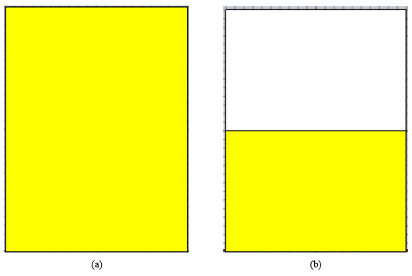
Fig. 12 - (a) full ground plane; (b) half ground plane
Table 11 and Table 12 shows the value of resonant frequency, return loss and gain for folded strip line antenna for both full ground plane and half ground plane designs.
Table 11 - S-parameter and antenna gain (Full ground)
Resonant frequency (GHz) | Return loss (dB) | Gain
4.04 | -15.919 | 0.29561

Table 12 - S-parameter and antenna gain (Half ground)
Resonant frequency (GHz) | Return loss (dB) | Gain
2.57 | -5.2241 | -10.867
3.3 | -7.3096 | -7.7051

By comparing the s-parameter for three ground plane design, it can be seen that the proposed design which has the length of 3mm is better and suitable for the antenna since it helps the antenna to achieve quad band frequency. Unlike the full and half ground plane design, these two designs only manage to obtain at most two frequency bands only. Furthermore, the frequency value for half ground plane is not valid due to their return loss value higher than -10 dB. In addition, the resonant frequencies are not the same as proposed in the project. The figure below shows the s-parameter comparison for three ground plane designs.
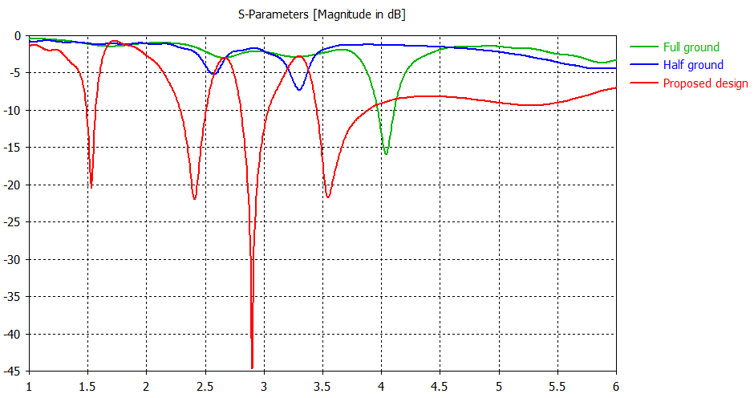
Fig. 13 - S-parameter comparison for ground plane designs
- Substrate Material
In this section, the RT Rodgers 5880 and RO 4730 will be used as the substrate material for this antenna in the simulation. The purpose of substituting these materials as the substrate is to see how the simulation will be affected due to different material used. According to the simulation results, it is shown that the antenna s-parameter value has some changes. For RT Rodgers 5880 material, the resonant frequencies obtained was 1.75 GHz, 2.8 GHz, 3.615 GHz and 4.4426 GHz. Meanwhile the return loss value is -22.556 dB, -36.028 dB, -20.303 dB and -16.519 dB respectively. So, even the substrate material changes, the antenna still manages to obtain quad-band frequency. The only issue is that the frequency value is not the same as the proposed value. The result for this antenna design was recorded and can be seen in Table 13.
Table 13 - S-parameter and antenna gain (RT Rodgers 5880)
Resonant frequency (GHz) | Return loss (dB) | Gain
1.75 | -22.556 | -3.941
2.8 | -36.028 | -2.0183
3.651 | -20.303 | -1.2191
4.4426 | -16.519 | 0.38003

Next, the FR-4 substrate was replaced by the material RO 4730. Based on the simulation result, the resonant frequencies for the antenna are 1.665 GHz, 2.625 GHz, 3.285 GHz and 4.03 GHz. The return loss value for each resonant frequency is -18.643 dB, -26.053 dB, -27.353 dB and -19.182 dB respectively. Compared to the s-parameter of FR-4 substrate, there are three frequencies that shifted to the right which is frequency 1.665 GHz, 3.285 GHz and 4.03 GHz while the other frequency shifted to the left. The results for this antenna have been recorded and shown in the table below.
Table 14 - S-parameter and antenna gain (RO 4730)
Resonant frequency (GHz) | Return loss (dB) | Gain
1.665 | -18.643 | -3.9429
2.625 | -26.053 | -1.9625
3.285 | -27.353 | -1.3386
4.03 | -19.182 | 0.11767

By comparing the results of these substrate material, it can be seen that FR-4 is the suited material to be used as the antenna substrate since it helps the antenna achieve the resonant frequency that is proposed in this project even the gains are low. Based on Table 4.3, the frequencies achieve by suing FR-4 as a substrate are 1.53 GHz, 2.41 GHz, 2.9 GHz and 3.545 GHz. Nevertheless, two of the resonant frequencies has different frequency application compared to the proposed value. The figure below shows the s-parameter comparison for material RT Rodgers 5880, RO 4730 and FR-4.
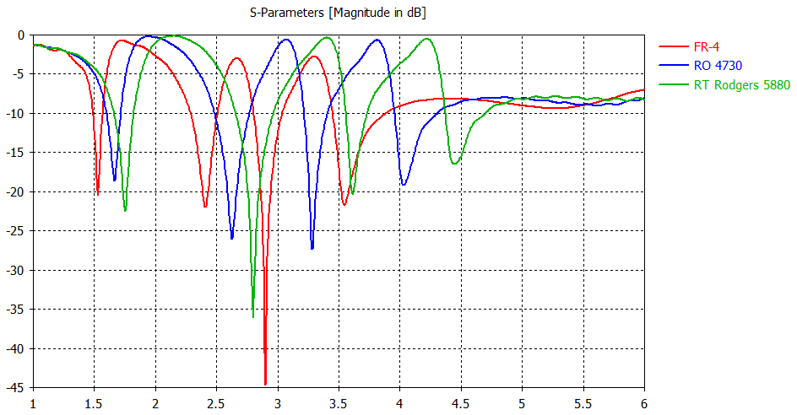
Fig. 14 - S-parameter comparison for substrate materials
- Conclusion
A quad band monopole antenna with eight symmetrical rectangular folded strip lines was designed. Based on the simulation results obtained and presented in this paper, the antenna manages to obtained quad band frequency even though two of the resonant frequency has different frequency band and application compared to the proposed application. However, all the frequencies obtained are valid and accepted since their return loss values are below than two (2). The resonant frequencies obtained also has difference in values after comparing them to the proposed values.
Based on this project, there are several recommendations can be applied to improve the antenna in the future work. One of them is to use the antenna for Global Positioning System (GPS) and Third Generation (3G) application since the results had proved that this antenna can be used for those application by generating 1.53 GHz and 2.9 GHz frequency in the simulation process. Other than that, the antenna can be improved by getting a higher gain for all resonant frequencies since all of them had low gains in the simulation. Last but not least, this antenna can be fabricated in the future work since this project only does a simulation process. By having both simulation and fabrication antenna, the results can be compared with each other and analyzed why there is a difference between them.
References
[1] Y. Zehforoosh and M. Rezvani, “A small quad-band monopole antenna with folded strip lines for WiMAX/WLAN and ITU applications,” J. Microwaves, Optoelectron. Electromagn. Appl., vol. 16, no. 4, pp. 1012-1018, 2017, doi: 10.1590/2179-10742017v16i41084.
[2] A. A. S. A. Jabar and D. K. Naji, “Design of miniaturized quad-band dual-arm spiral patch antenna for RFID, WLAN and WiMAX applications,” Prog. Electromagn. Res. C, vol. 91, no. March, pp. 97-113, 2019, doi: 10.2528/pierc19011706.
[3] S. Srivastava, A. Khandelwal, and D. S. Sharma, “Microstrip Patch Antenna: A Survey,” IOSR J. Electr. Electron. Eng., vol. 9, no. 4, pp. 07-13, 2014, doi: 10.9790/1676-09420713.
[4] S. Bisht, S. Saini, V. Prakash, and B. Nautiyal, “Study The Various Feeding Techniques of Microstrip Antenna Using Design and Simulation Using CST Microwave Studio,” Int. J. Emerg. Technol. Adv. Eng., vol. 4, no. 9, pp. 318-324, 2014.
[5] D. K. Naji, “Design of Compact Dual-band and Tri-band Microstrip Patch Antennas,” Int. J. Electromagn. Appl. 2018, vol. 8, no. 1, pp. 26-34, 2018, doi: 10.5923/j.ijea.20180801.02.
[6] M. I. Aksun, “Introduction to Rectangular Waveguides.” http://www.ee.bilkent.edu.tr/~microwave/programs/magnetic/rect/info.htm (accessed Jul. 28, 2021).
[7] Y. Yao, W. Chen, X. Chen, and J. Yu, “Analysis and Design of a Novel Multiband Antenna for Mobile Terminals,” Int. J. Antennas Propag., vol. 2015, 2015, doi: 10.1155/2015/591269.
[8] Y. K. Choukiker, “Analysis of Dual Band Rectangular Microstrip Antenna", Dep. Electron. Commun. Eng. Natl. Inst. Technol. Rourkela-769008, February, 2009.
[9] D. Karkhur, “Review of Techniques to Design Multiband Microstrip Patch Antennas,” Int. J. latest trends Eng. Technol., vol. 7, no. 4, pp. 6-10, 2016.
[10] S. Onodera, R. Ishikawa, A. Saitou, and K. Honjo, “Multi-band reconfigurable antennas embedded with lumped-element passive components and varactors,” Asia-Pacific Microw. Conf. Proceedings, APMC, pp. 137-139, 2013, doi: 10.1109/APMC.2013.6695216.
[11] I. Singh and V. S. Tripathi, “Microstrip Patch Antenna and its Applications : a Survey,” vol. 2, no. 5, pp. 1595-1599, 2011.
[12] MCL, “FR4 Printed Circuit Board Material | Guide & Request Quote.” https://www.mclpcb.com/blog/fr4-guide/ (accessed Jul. 28, 2021).
[13] S. N. Bhavanam and R. S. Kalyan, “Design of a Novel Coaxial Feed Triple Frequency Patch Antenna with Slots and Shorting Pin,” Procedia Comput. Sci., vol. 85, no. June, pp. 345-351, 2016, doi: 10.1016/j.procs.2016.05.242.
[14] A. Samir, A. Fawzy, H. M. Abd, and E. Kader, “Design of a Multi-Band U-Slot Microstrip Patch Antenna,” no. December, 2019, doi: 10.9790/2834.
[15] Muhammad Fikri Bin Abdul Aziz, “Miniaturized Quad-band Dual-Arm Spiral PatchAntenna for RFID, WLAN and WiMAX Application,” 2020.
[16] Techopedia, “What is a Feed Line? - Definition from Techopedia,” 2016. https://www.techopedia.com/definition/16795/feed-line (accessed Jul. 28, 2021).
[17] S. Jordaan, M. O. Odhiambo, and L. Combrinck, “A Miniaturisation Technique for a 1 . 57542 GHz GPS Patch Antenna,” Design, no. November 2015, 2010.
[18] R. Tiwari, A. Lala, V. K. Singh, and A. Saxena, “2.9 GHz Plus Slotted Square Microstrip Patch Antenna,” no. April 2018, 2017.

